Experiment – 10
Schedules
Creating Scheduled Workflows in Zoho Creator
Department of Computer Science and Engineering
Student Name: SANDEEP K
Roll No: 240701464
Application Name: Parking Slot Reservation (Purchase Request / Procurement Application)

Objective
To create a Schedule workflow in Zoho Creator that runs an action automatically at a specified date and time and repeats at a chosen interval (daily, weekly, or monthly), and to use it to send an email notification for purchase approval requests.

Introduction
A Schedule is a type of workflow that is not triggered by a user submitting or editing a record. Instead, it runs on its own at a set time, so that routine work such as reminders, reports, and follow-ups does not depend on someone remembering to do it. A schedule can run once, or repeat daily, weekly, monthly, or yearly from a chosen start date and time. It can also be tied to a date field stored in the records, so that actions run on the date saved in each record. When the schedule fires, it executes the actions added to it, such as sending an email or SMS, adding or updating records in another form, or running a Deluge script.

Schedule Requirements
The schedule workflow in this experiment was required to support three repetition intervals: daily, weekly, and monthly. The interval is chosen in the Run field while the schedule is being created.
Table 10.1: Schedule frequencies required in this experiment.
Frequency | Meaning | Example use in this application
Daily | Runs every day at the chosen time | Daily email reminder of purchase requests awaiting approval
Weekly | Runs once every week on the day of the start date | Weekly summary of pending requests sent to the HOD
Monthly | Runs once every month on the date of the start date | Monthly report of approved purchases and budget use
Table 10.2: Settings used to create the schedule.
Setting | Value | Purpose
Schedule type | Specify Date and Time | Runs at a fixed date and time, rather than from a date field in a record
Start date and time | 20-Oct-2026, 21:00:00 | When the schedule runs for the first time
Run | Daily | How often the schedule repeats after the start date
Workflow name | Approval submission requezt | Name under which the schedule is saved (as typed in the application)
Action type | Notification → Send email | Action carried out each time the schedule runs

Screenshot-based lab record
The following pages contain the actual Zoho Creator screenshots of the schedule configuration.

Screenshots 1 – Schedules Tab
The Schedules tab of the Workflow section lists the scheduled workflows of the application. It is currently empty and explains that schedules run actions at a specific time, on a scheduled interval, or at times saved in records. A new schedule is started with Create Workflow or New Workflow.
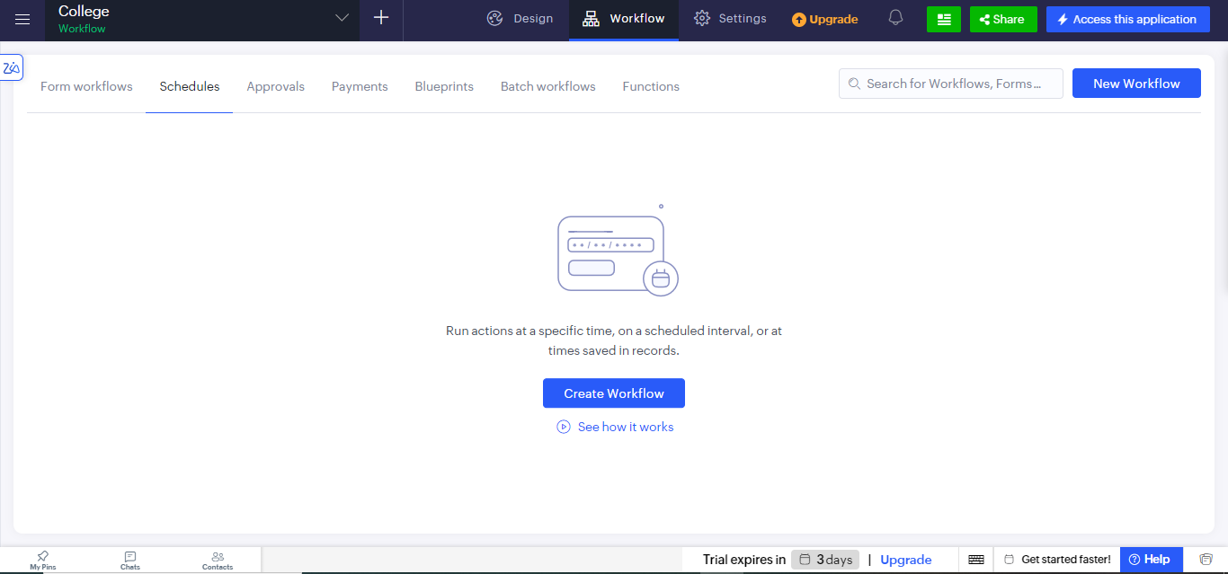
Figure 1: Schedules tab of the Workflow section before any schedule is created.

Screenshots 2 – Creating the Schedule
Choosing Create Workflow opens the Run workflow on a scheduled date page. It offers two options: Specify Date and Time, and Choose a Date Field. The first option was used. It asks for the start date and time, how often to Run the schedule, and a name for the workflow.
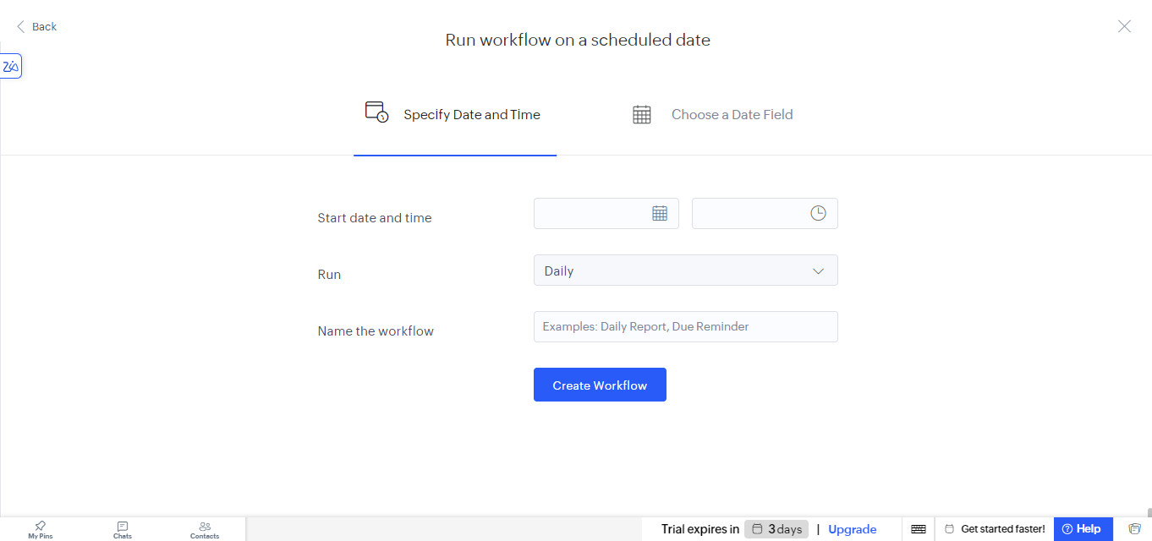
Figure 2.1: Run workflow on a scheduled date page with the Specify Date and Time option.
The start date was set to 20-Oct-2026 and the time to 21:00:00. The Run drop-down lists the repetition intervals Daily, Weekly, Monthly, Yearly, and Once. Daily, Weekly, and Monthly are the intervals required in this experiment, and Daily was selected for this schedule.
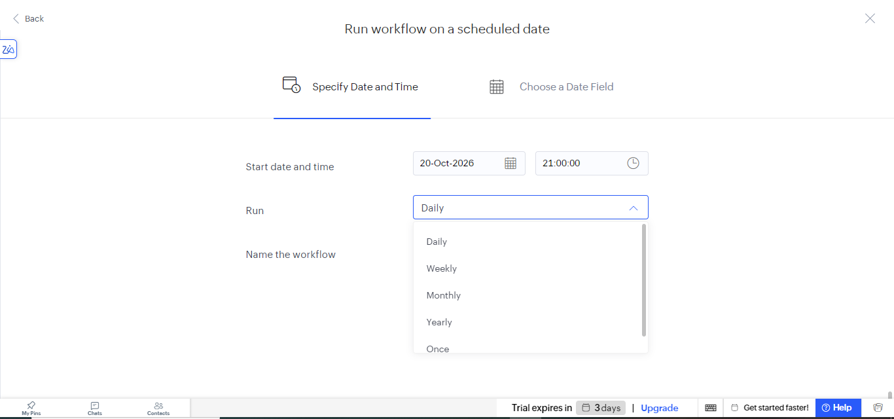
Figure 2.2: Start date and time set, and the Run drop-down showing Daily, Weekly, Monthly, Yearly, and Once.

Screenshots 3 – Adding an Action
After the schedule was named and created, its header shows the trigger as On 20-Oct-2026 at 21:00:00 followed by the workflow name Approval submission requezt, with a note that actions run based on the date and time. Add New Action opens a panel with three action types: Notification (email, SMS, or redirect to a URL), Data access (add or update records in another form), and Deluge script.
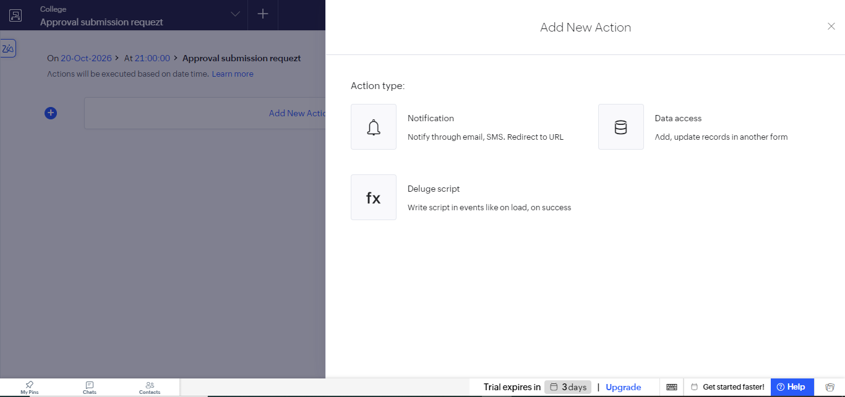
Figure 3.1: Add New Action panel of the scheduled workflow.
The Notification type was chosen, which opens the Send email page. The From address is set to the admin user ID, and the recipient is entered in the To field. Cc, Bcc, and Reply-to can also be added, and the Subject and Message are written in the editor below. Selecting Save stores the action.
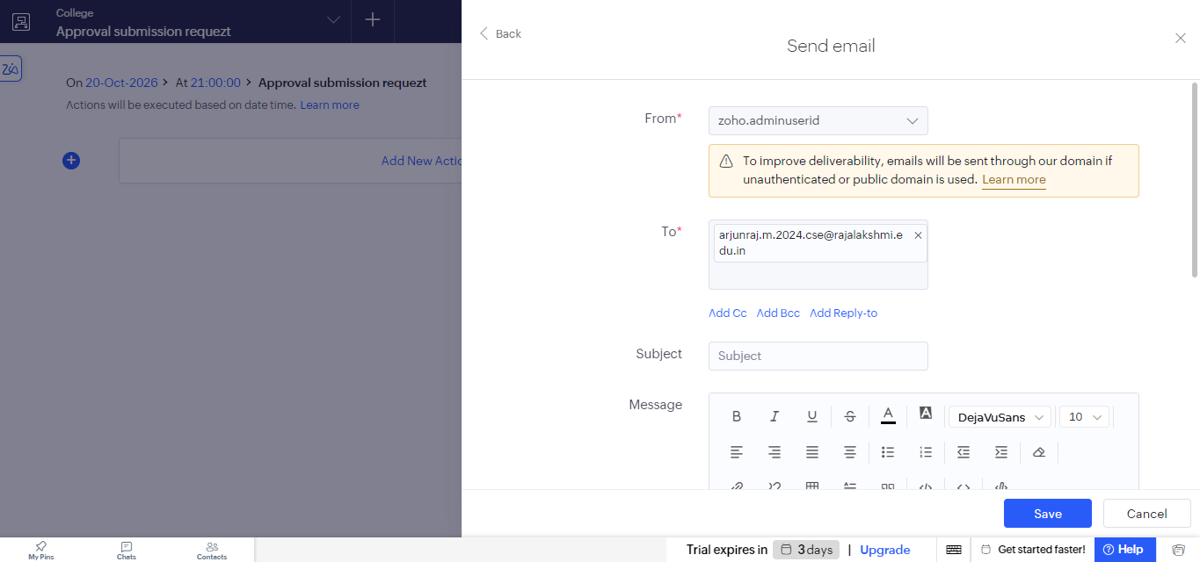
Figure 3.2: Send email action configured for the scheduled workflow.

Observation
The schedule was set up without writing any code. Once the start date, time, and interval were given, Zoho Creator ran the attached action at the set time with no user action needed. The same schedule can be changed from Daily to Weekly or Monthly just by choosing a different value in the Run field, so the three required intervals are handled by one feature. The Choose a Date Field option provides a second way to schedule, by running actions on a date stored in each record, such as a due date.
A schedule differs from the form workflows and blueprint of the earlier experiments. A form workflow reacts to a form event such as submitting or editing a record, and a blueprint controls the steps a record must follow. A schedule is driven by time alone, which makes it suitable for reminders and periodic reports.

Result
A scheduled workflow named Approval submission requezt was successfully created in the Zoho Creator application. It starts on 20-Oct-2026 at 21:00:00, repeats daily, and has a Send email notification action added to it. The Run option also provides the Weekly and Monthly intervals required by the experiment.

